# 按钮

## 默认按钮



<a href="#" class="ui-btn">Anchor</a>

## 圆角按钮



<a href="#" class="ui-btn ui-corner-all">Anchor</a>

## 图形按钮



<a href="#" class="ui-btn ui-icon-delete ui-btn-icon-notext ui-corner-all">No text</a>



<div id="custom-border-radius">

    <a href="#" class="ui-btn ui-icon-delete ui-btn-icon-notext ui-corner-all">No text</a>

</div>

## 阴影按钮



<a href="#" class="ui-btn ui-shadow">Anchor</a>

## 内联按钮

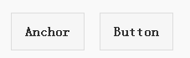

<a href="#" class="ui-btn ui-btn-inline">Anchor</a>

<button class="ui-btn ui-btn-inline">Button</button>

## 按钮主题

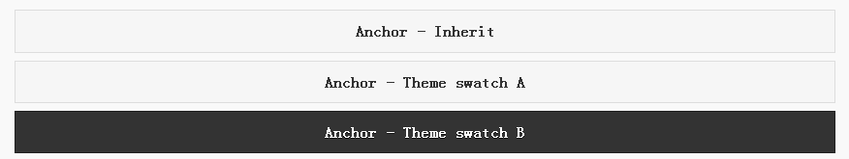

<a href="#" class="ui-btn">Anchor - Inherit</a>

<a href="#" class="ui-btn ui-btn-a">Anchor - Theme swatch A</a>

<a href="#" class="ui-btn ui-btn-b">Anchor - Theme swatch B</a>

## 迷你按钮



<a href="#" class="ui-btn ui-mini">Anchor</a>

## 带图标按钮



<a href="#" class="ui-btn ui-icon-delete ui-btn-icon-left">Anchor</a>

## 图标位置按钮

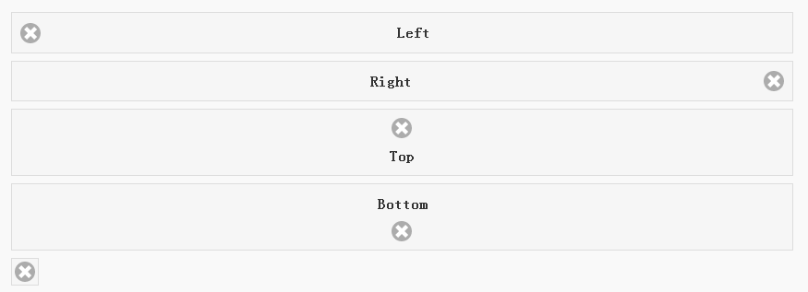

<a href="#" class="ui-btn ui-icon-delete ui-btn-icon-left">Left</a>

<a href="#" class="ui-btn ui-icon-delete ui-btn-icon-right">Right</a>

<a href="#" class="ui-btn ui-icon-delete ui-btn-icon-top">Top</a>

<a href="#" class="ui-btn ui-icon-delete ui-btn-icon-bottom">Bottom</a>

<a href="#" class="ui-btn ui-icon-delete ui-btn-icon-notext">Icon only</a>

## 图标位置按钮-内联

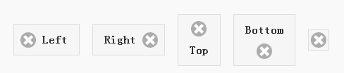

<a href="#" class="ui-btn ui-btn-inline ui-icon-delete ui-btn-icon-left">Left</a>

<a href="#" class="ui-btn ui-btn-inline ui-icon-delete ui-btn-icon-right">Right</a>

<a href="#" class="ui-btn ui-btn-inline ui-icon-delete ui-btn-icon-top">Top</a>

<a href="#" class="ui-btn ui-btn-inline ui-icon-delete ui-btn-icon-bottom">Bottom</a>

<a href="#" class="ui-btn ui-btn-inline ui-icon-delete ui-btn-icon-notext">Icon only</a>

## 失效按钮



<a href="#" class="ui-btn ui-state-disabled">Disabled anchor via class</a>

## 原始按钮



<button data-role="none">Button</button>

# 复选框

## 默认复选框



<form>

    <label>

        <input type="checkbox" name="checkbox-0 ">Check me

    </label>

</form>

## 迷你复选框



<form>

    <input type="checkbox" name="checkbox-mini-0" id="checkbox-mini-0" data-mini="true">

    <label for="checkbox-mini-0">I agree</label>

</form>

## 垂直组合复选框

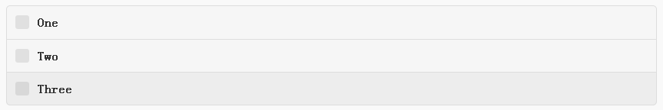

<form>

    <fieldset data-role="controlgroup">

        <legend>Vertical:</legend>

        <input type="checkbox" name="checkbox-v-2a" id="checkbox-v-2a">

        <label for="checkbox-v-2a">One</label>

        <input type="checkbox" name="checkbox-v-2b" id="checkbox-v-2b">

        <label for="checkbox-v-2b">Two</label>

        <input type="checkbox" name="checkbox-v-2c" id="checkbox-v-2c">

        <label for="checkbox-v-2c">Three</label>

    </fieldset>

</form>

## 水平组合复选框



<form>

    <fieldset data-role="controlgroup" data-type="horizontal">

        <legend>Horizontal:</legend>

        <input type="checkbox" name="checkbox-h-2a" id="checkbox-h-2a">

        <label for="checkbox-h-2a">One</label>

        <input type="checkbox" name="checkbox-h-2b" id="checkbox-h-2b">

        <label for="checkbox-h-2b">Two</label>

        <input type="checkbox" name="checkbox-h-2c" id="checkbox-h-2c">

        <label for="checkbox-h-2c">Three</label>

    </fieldset>

</form>

## 位置复选框

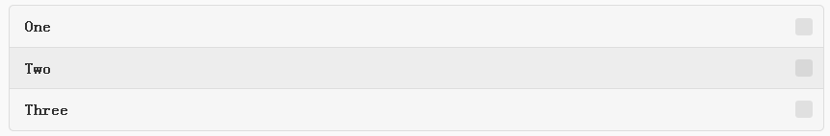

<form>

    <fieldset data-role="controlgroup" data-iconpos="right">

        <legend>Icon right:</legend>

        <input type="checkbox" name="checkbox-h-6a" id="checkbox-h-6a">

        <label for="checkbox-h-6a">One</label>

        <input type="checkbox" name="checkbox-h-6b" id="checkbox-h-6b">

        <label for="checkbox-h-6b">Two</label>

        <input type="checkbox" name="checkbox-h-6c" id="checkbox-h-6c">

        <label for="checkbox-h-6c">Three</label>

    </fieldset>

</form>

## 样式复选框

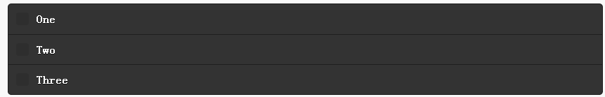

<form>

    <fieldset data-role="controlgroup">

        <legend>Swatch B:</legend>

        <input type="checkbox" name="checkbox-t-2a" id="checkbox-t-2a" data-theme="b">

        <label for="checkbox-t-2a">One</label>

        <input type="checkbox" name="checkbox-t-2b" id="checkbox-t-2b" data-theme="b">

        <label for="checkbox-t-2b">Two</label>

        <input type="checkbox" name="checkbox-t-2c" id="checkbox-t-2c" data-theme="b">

        <label for="checkbox-t-2c">Three</label>

    </fieldset>

</form>

## 失效复选框



<form>

        <input disabled="" type="checkbox" name="checkbox-t-2a" id="checkbox-t-2a" data-theme="a">

        <label for="checkbox-t-2a">One</label>

</form>

# 单选按钮

## 默认单选按钮

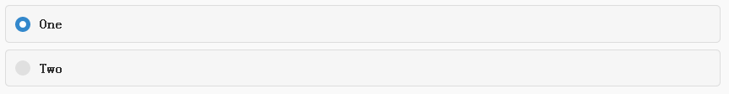

<form>

    <label>

        <input type="radio" name="radio-choice-0" id="radio-choice-0a">One

    </label>

    <label for="radio-choice-0b">Two</label>

    <input type="radio" name="radio-choice-0" id="radio-choice-0b" class="custom">

</form>

## 垂直型单选按钮

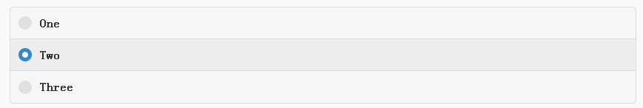

<form>

        <fieldset data-role="controlgroup">

        <legend>Vertical:</legend>

        <input type="radio" name="radio-choice-v-2" id="radio-choice-v-2a" value="on" checked="checked">

        <label for="radio-choice-v-2a">One</label>

        <input type="radio" name="radio-choice-v-2" id="radio-choice-v-2b" value="off">

        <label for="radio-choice-v-2b">Two</label>

        <input type="radio" name="radio-choice-v-2" id="radio-choice-v-2c" value="other">

        <label for="radio-choice-v-2c">Three</label>

    </fieldset>

</form>

## 水平型单选按钮



<form>

    <fieldset data-role="controlgroup" data-type="horizontal">

        <legend>Horizontal:</legend>

        <input type="radio" name="radio-choice-h-2" id="radio-choice-h-2a" value="on" checked="checked">

        <label for="radio-choice-h-2a">One</label>

        <input type="radio" name="radio-choice-h-2" id="radio-choice-h-2b" value="off">

        <label for="radio-choice-h-2b">Two</label>

        <input type="radio" name="radio-choice-h-2" id="radio-choice-h-2c" value="other">

        <label for="radio-choice-h-2c">Three</label>

    </fieldset>

</form>

## 迷你型单选按钮

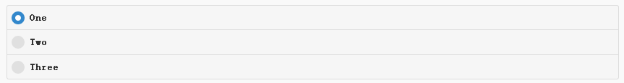

<form>

    <fieldset data-role="controlgroup" data-mini="true">

        <legend>Vertical, icon right, mini sized:</legend>

        <input type="radio" name="radio-choice-v-6" id="radio-choice-v-6a" value="on" checked="checked">

        <label for="radio-choice-v-6a">One</label>

        <input type="radio" name="radio-choice-v-6" id="radio-choice-v-6b" value="off">

        <label for="radio-choice-v-6b">Two</label>

        <input type="radio" name="radio-choice-v-6" id="radio-choice-v-6c" value="other">

        <label for="radio-choice-v-6c">Three</label>

    </fieldset>

</form>

## 位置型单选按钮

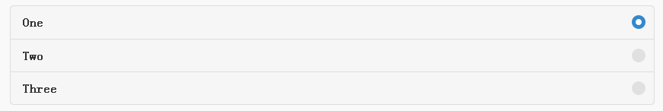

<form>

    <fieldset data-role="controlgroup" data-iconpos="right">

        <legend>Vertical, icon right:</legend>

        <input type="radio" name="radio-choice-w-6" id="radio-choice-w-6a" value="on" checked="checked">

        <label for="radio-choice-w-6a">One</label>

        <input type="radio" name="radio-choice-w-6" id="radio-choice-w-6b" value="off">

        <label for="radio-choice-w-6b">Two</label>

        <input type="radio" name="radio-choice-w-6" id="radio-choice-w-6c" value="other">

        <label for="radio-choice-w-6c">Three</label>

    </fieldset>

</form>

## 主题型单选按钮



<form>

    <fieldset data-role="controlgroup" data-theme="b" data-type="horizontal">

        <legend>Horizontal:</legend>

        <input type="radio" name="radio-choice-t-6" id="radio-choice-t-6a" value="on" checked="checked">

        <label for="radio-choice-t-6a">One</label>

        <input type="radio" name="radio-choice-t-6" id="radio-choice-t-6b" value="off">

        <label for="radio-choice-t-6b">Two</label>

        <input type="radio" name="radio-choice-t-6" id="radio-choice-t-6c" value="other">

        <label for="radio-choice-t-6c">Three</label>

    </fieldset>

</form>

## 失效型单选按钮

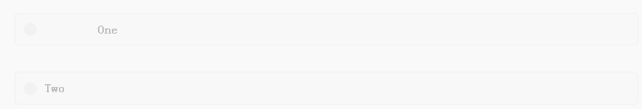

<form>

    <label>

        <input type="radio" name="radio-choice-7" id="radio-choice-7a" disabled="disabled">One

    </label>

    <label for="radio-choice-7b">Two</label>

    <input type="radio" name="radio-choice-7" id="radio-choice-7b" disabled="disabled">

</form>

# 折叠组件

## 基本型折叠组件



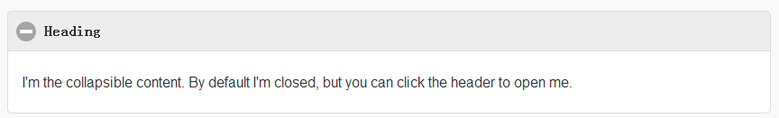

<div data-role="collapsible">

    <h4>Heading</h4>

    <p>I'm the collapsible content. By default I'm closed, but you can click the header to open me.</p>

</div>

## 主题型折叠组件



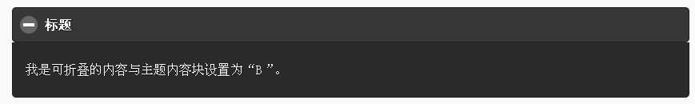

<div data-role="collapsible" data-theme="b" data-content-theme="b">

    <h4>Heading</h4>

    <p>I'm the collapsible content with a themed content block set to "b".</p>

</div>



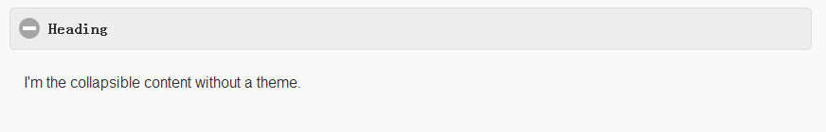

<div data-role="collapsible" data-content-theme="false">

    <h4>Heading</h4>

    <p>I'm the collapsible content without a theme.</p>

</div>

## 扩展型折叠组件



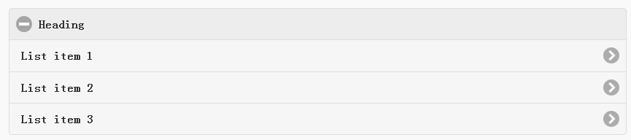

<div data-role="collapsible" data-collapsed="false">

    <h4>Heading</h4>

    <ul data-role="listview">

        <li><a href="#">List item 1</a></li>

        <li><a href="#">List item 2</a></li>

        <li><a href="#">List item 3</a></li>

    </ul>

</div>

## 迷你型折叠组件



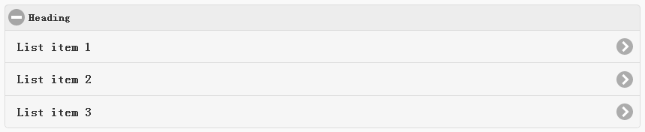

<div data-role="collapsible" data-mini="true">

    <h4>Heading</h4>

    <ul data-role="listview">

        <li><a href="#">List item 1</a></li>

        <li><a href="#">List item 2</a></li>

        <li><a href="#">List item 3</a></li>

    </ul>

</div>

## 图标型折叠组件



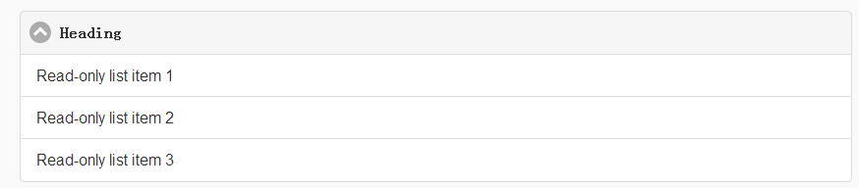

<div data-role="collapsible" data-collapsed-icon="carat-d" data-expanded-icon="carat-u">

    <h4>Heading</h4>

    <ul data-role="listview" data-inset="false">

        <li>Read-only list item 1</li>

        <li>Read-only list item 2</li>

        <li>Read-only list item 3</li>

    </ul>

</div>

## 位置型折叠组件



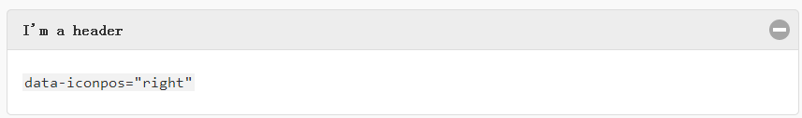

data-iconpos="right"

## 表单型折叠组件



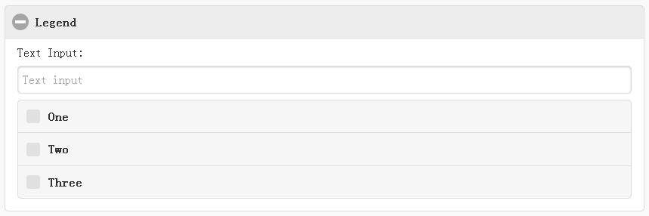

<form>

    <fieldset data-role="collapsible">

        <legend>Legend</legend>

        <label for="textinput-f">Text Input:</label>

        <input type="text" name="textinput-f" id="textinput-f" placeholder="Text input" value="">

        <div data-role="controlgroup">

            <input type="checkbox" name="checkbox-1-a" id="checkbox-1-a">

            <label for="checkbox-1-a">One</label>

            <input type="checkbox" name="checkbox-2-a" id="checkbox-2-a">

            <label for="checkbox-2-a">Two</label>

            <input type="checkbox" name="checkbox-3-a" id="checkbox-3-a">

            <label for="checkbox-3-a">Three</label>

        </div>

    </fieldset>

</form>

## 无边角折叠组件



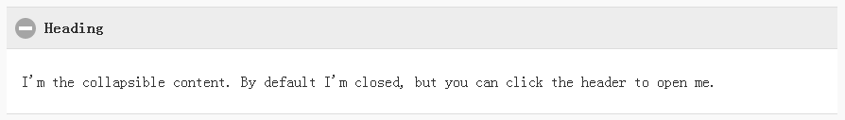

<div data-role="collapsible" data-inset="false">

    <h4>Heading</h4>

    <p>I'm the collapsible content. By default I'm closed, but you can click the header to open me.</p>

</div>

## 独立式折叠组件

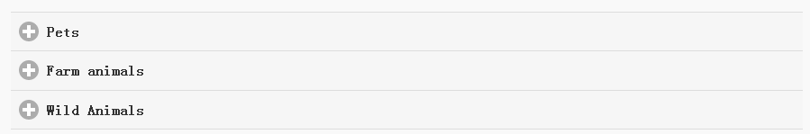

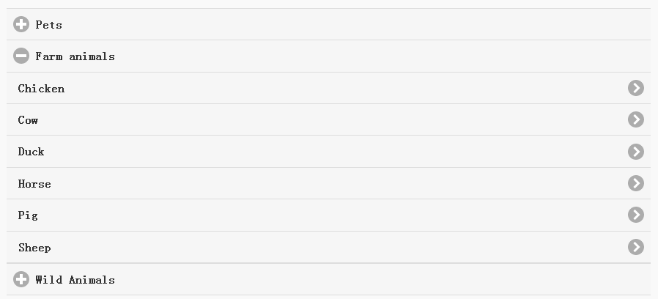

<div data-role="collapsible" data-inset="false">

    <h3>Pets</h3>

    <ul data-role="listview">

        <li><a href="#">Canary</a></li>

        <li><a href="#">Cat</a></li>

        <li><a href="#">Dog</a></li>

        <li><a href="#">Gerbil</a></li>

        <li><a href="#">Iguana</a></li>

        <li><a href="#">Mouse</a></li>

    </ul>

</div><!-- /collapsible -->

<div data-role="collapsible" data-inset="false">

    <h3>Farm animals</h3>

    <ul data-role="listview">

        <li><a href="#">Chicken</a></li>

        <li><a href="#">Cow</a></li>

        <li><a href="#">Duck</a></li>

        <li><a href="#">Horse</a></li>

        <li><a href="#">Pig</a></li>

        <li><a href="#">Sheep</a></li>

    </ul>

</div><!-- /collapsible -->

<div data-role="collapsible" data-inset="false">

    <h3>Wild Animals</h3>

    <ul data-role="listview">

        <li><a href="#">Aardvark</a></li>

        <li><a href="#">Alligator</a></li>

        <li><a href="#">Ant</a></li>

        <li><a href="#">Bear</a></li>

        <li><a href="#">Beaver</a></li>

        <li><a href="#">Cougar</a></li>

        <li><a href="#">Dingo</a></li>

    </ul>

</div><!-- /collapsible -->

## 动态性折叠组件

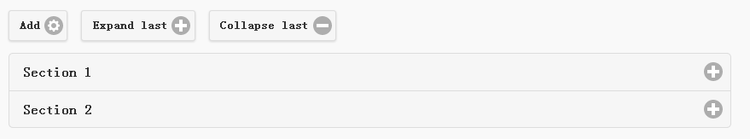

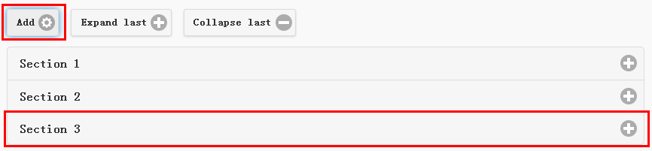

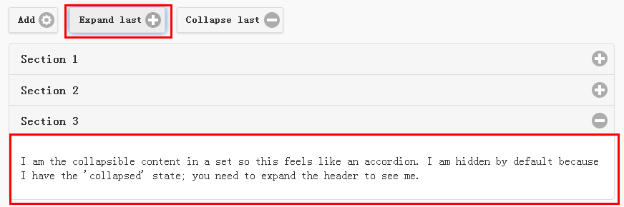

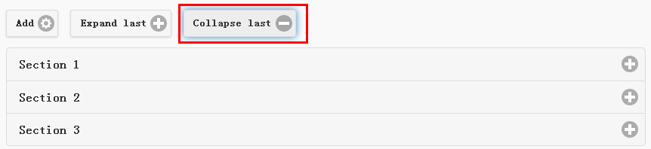

<button type="button" data-icon="gear" data-iconpos="right" data-mini="true" data-inline="true" id="add">Add</button>

<button type="button" data-icon="plus" data-iconpos="right" data-mini="true" data-inline="true" id="expand">Expand last</button>

<button type="button" data-icon="minus" data-iconpos="right" data-mini="true" data-inline="true" id="collapse">Collapse last</button>

<div data-role="collapsibleset" data-content-theme="a" data-iconpos="right" id="set">

    <div data-role="collapsible" id="set1" data-collapsed="true">

        <h3>Section 1</h3>

        <p>I'm the collapsible content.</p>

    </div>

</div>

$( document ).on( "pagecreate", function() {

    var nextId = 1;

    $("#add").click(function() {

        nextId++;

        var content = "<div data-role='collapsible' id='set" + nextId + "'><h3>Section " + nextId + "</h3><p>I am the collapsible content in a set so this feels like an accordion. I am hidden by default because I have the 'collapsed' state; you need to expand the header to see me.</p></div>";

        $( "#set" ).append( content ).collapsibleset( "refresh" );

    });

    $( "#expand" ).click(function() {

        $("#set").children(":last").collapsible( "expand" );

    });

    $( "#collapse" ).click(function() {

        $( "#set" ).children( ":last" ).collapsible( "collapse" );

    });

});

## 互斥型折叠组件

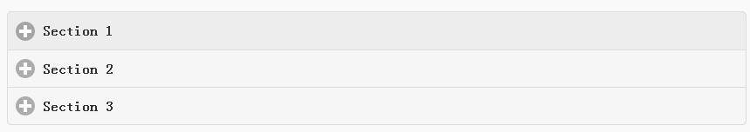

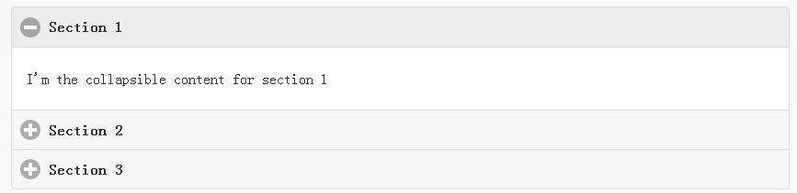

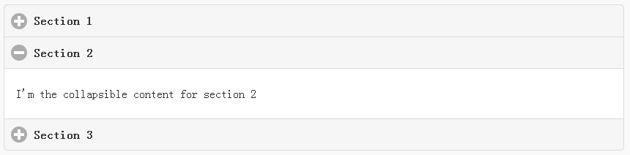

<div data-role="collapsibleset" data-theme="a" data-content-theme="a">

    <div data-role="collapsible">

        <h3>Section 1</h3>

    <p>I'm the collapsible content for section 1</p>

    </div>

    <div data-role="collapsible">

        <h3>Section 2</h3>

    <p>I'm the collapsible content for section 2</p>

    </div>

    <div data-role="collapsible">

        <h3>Section 3</h3>

    <p>I'm the collapsible content for section 3</p>

    </div>

</div>

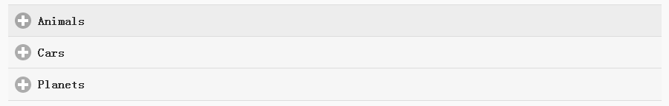

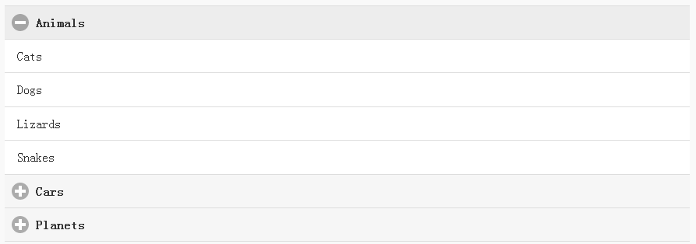

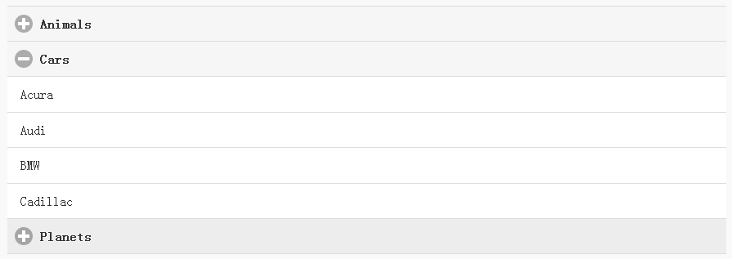

<div data-role="collapsibleset" data-inset="false">

    <div data-role="collapsible">

        <h3>Animals</h3>

        <ul data-role="listview" data-inset="false">

            <li>Cats</li>

            <li>Dogs</li>

            <li>Lizards</li>

            <li>Snakes</li>

        </ul>

    </div>

    <div data-role="collapsible">

        <h3>Cars</h3>

        <ul data-role="listview" data-inset="false">

            <li>Acura</li>

            <li>Audi</li>

            <li>BMW</li>

            <li>Cadillac</li>

        </ul>

    </div>

    <div data-role="collapsible">

        <h3>Planets</h3>

        <ul data-role="listview" data-inset="false">

            <li>Earth</li>

            <li>Jupiter</li>

            <li>Mars</li>

            <li>Mercury</li>

        </ul>

    </div>

</div>

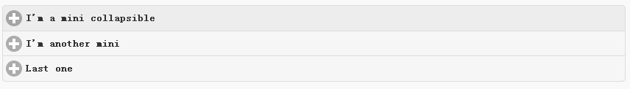

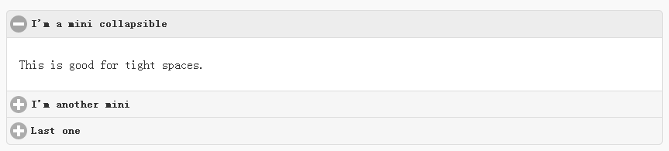

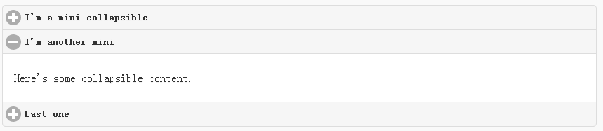

<div data-role="collapsibleset" data-theme="a" data-content-theme="a" data-mini="true">

    <div data-role="collapsible">

        <h3>I'm a mini collapsible</h3>

    <p>This is good for tight spaces.</p>

    </div>

    <div data-role="collapsible">

        <h3>I'm another mini</h3>

    <p>Here's some collapsible content.</p>

    </div>

    <div data-role="collapsible">

        <h3>Last one</h3>

    <p>Final bit of collapsible content.</p>

    </div>

</div>

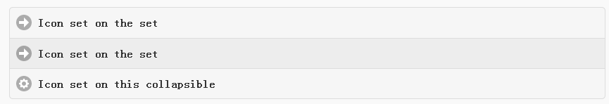

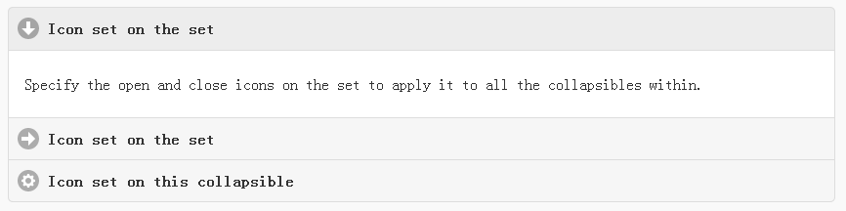

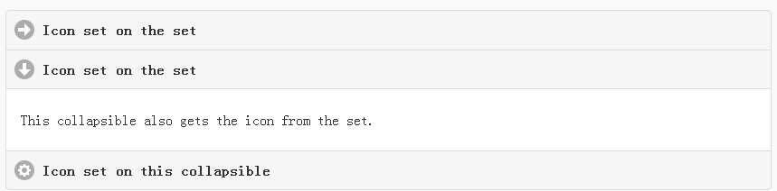

<div data-role="collapsibleset" data-theme="a" data-content-theme="a" data-collapsed-icon="arrow-r" data-expanded-icon="arrow-d">

    <div data-role="collapsible">

        <h3>Icon set on the set</h3>

    <p>Specify the open and close icons on the set to apply it to all the collapsibles within.</p>

    </div>

    <div data-role="collapsible">

        <h3>Icon set on the set</h3>

    <p>This collapsible also gets the icon from the set.</p>

    </div>

    <div data-role="collapsible" data-collapsed-icon="gear" data-expanded-icon="delete">

        <h3>Icon set on this collapsible</h3>

    <p>The icons here are applied to this collapsible specifically, thus overriding the set icons.</p>

    </div>

</div>

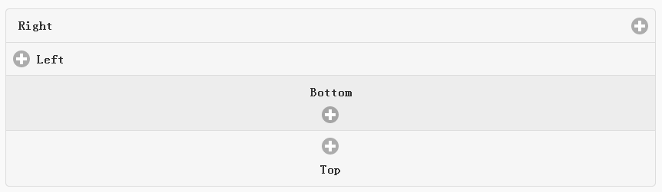

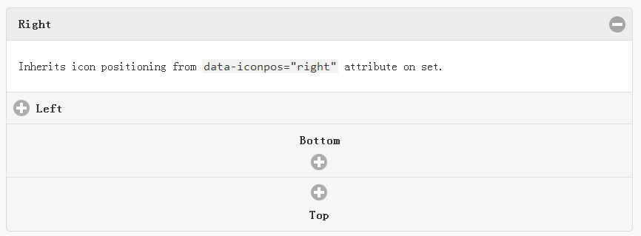

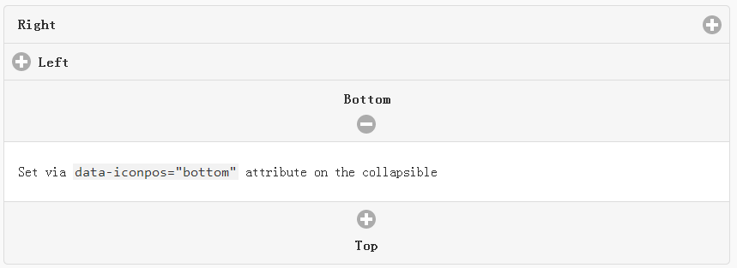

<div data-role="collapsibleset" data-theme="a" data-content-theme="a" data-iconpos="right">

    <div data-role="collapsible">

        <h3>Right</h3>

    <p>Inherits icon positioning from <code>data-iconpos="right"</code> attribute on set.</p>

    </div>

    <div data-role="collapsible" data-iconpos="left">

        <h3>Left</h3>

    <p>Set via <code>data-iconpos="left"</code> attribute on the collapsible</p>

    </div>

    <div data-role="collapsible" data-iconpos="bottom">

        <h3>Bottom</h3>

    <p>Set via <code>data-iconpos="bottom"</code> attribute on the collapsible</p>

    </div>

    <div data-role="collapsible" data-iconpos="top">

        <h3>Top</h3>

    <p>Set via <code>data-iconpos="top"</code> attribute on the collapsible</p>

    </div>

</div>

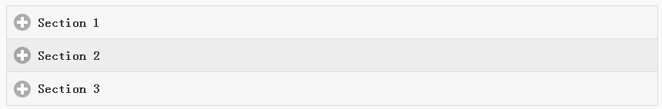

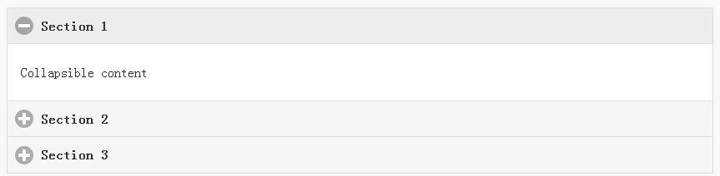

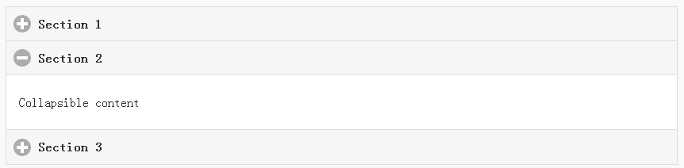

<div data-role="collapsibleset" data-corners="false" data-theme="a" data-content-theme="a">

    <div data-role="collapsible">

        <h3>Section 1</h3>

    <p>Collapsible content</p>

    </div>

    <div data-role="collapsible">

        <h3>Section 2</h3>

    <p>Collapsible content</p>

    </div>

    <div data-role="collapsible">

        <h3>Section 3</h3>

    <p>Collapsible content</p>

    </div>

</div>

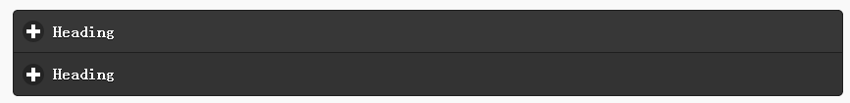

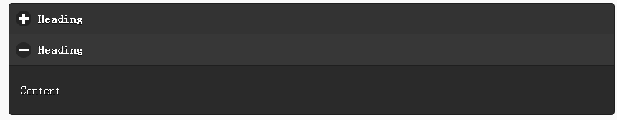

<div data-role="collapsibleset" data-theme="b" data-content-theme="b">

    <div data-role="collapsible">

        <h3>Heading</h3>

        <p>Content</p>

    </div>

    <div data-role="collapsible">

        <h3>Heading</h3>

        <p>Content</p>

    </div>

</div>

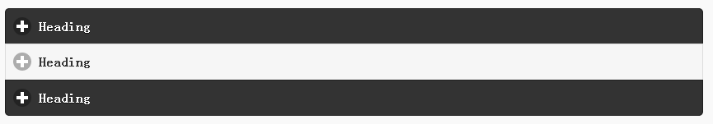

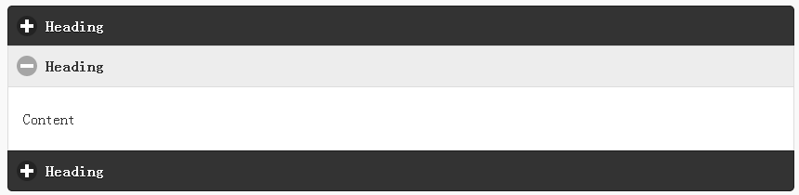

<div data-role="collapsibleset" data-theme="b" data-content-theme="b">

    <div data-role="collapsible">

        <h3>Heading</h3>

        <p>Content</p>

    </div>

    <div data-role="collapsible" data-theme="a" data-content-theme="a">

        <h3>Heading</h3>

        <p>Content</p>

    </div>

    <div data-role="collapsible">

        <h3>Heading</h3>

        <p>Content</p>

    </div>

</div>

# 导航按钮

## 垂直型导航按钮

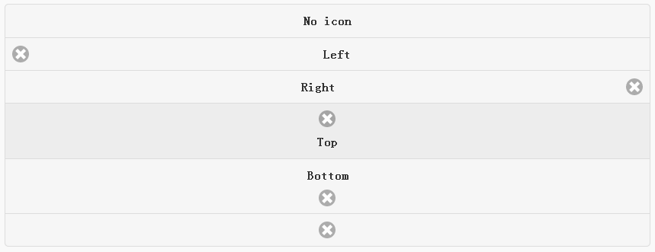

<div data-role="controlgroup">

    <a href="#" class="ui-btn ui-corner-all">No icon</a>

    <a href="#" class="ui-btn ui-corner-all ui-icon-delete ui-btn-icon-left">Left</a>

    <a href="#" class="ui-btn ui-corner-all ui-icon-delete ui-btn-icon-right">Right</a>

    <a href="#" class="ui-btn ui-corner-all ui-icon-delete ui-btn-icon-top">Top</a>

    <a href="#" class="ui-btn ui-corner-all ui-icon-delete ui-btn-icon-bottom">Bottom</a>

    <a href="#" class="ui-btn ui-corner-all ui-icon-delete ui-btn-icon-notext">Icon only</a>

</div>

迷你型垂直导航按钮

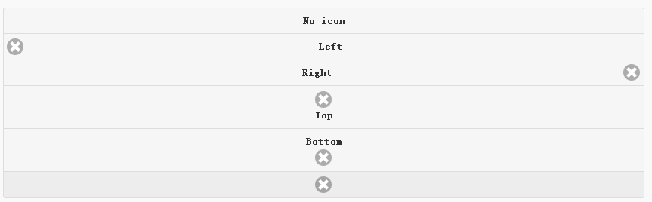

<div data-role="controlgroup" data-mini="true">

    <a href="#" class="ui-btn ui-corner-all">No icon</a>

    <a href="#" class="ui-btn ui-corner-all ui-icon-delete ui-btn-icon-left">Left</a>

    <a href="#" class="ui-btn ui-corner-all ui-icon-delete ui-btn-icon-right">Right</a>

    <a href="#" class="ui-btn ui-corner-all ui-icon-delete ui-btn-icon-top">Top</a>

    <a href="#" class="ui-btn ui-corner-all ui-icon-delete ui-btn-icon-bottom">Bottom</a>

    <a href="#" class="ui-btn ui-corner-all ui-icon-delete ui-btn-icon-notext">Icon only</a>

</div>

## 水平型导航按钮

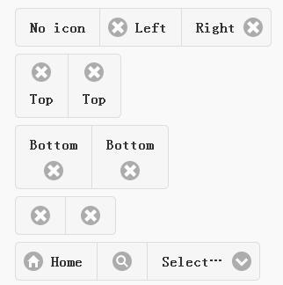

<div data-role="controlgroup" data-type="horizontal">

    <a href="#" class="ui-btn ui-corner-all">No icon</a>

    <a href="#" class="ui-btn ui-corner-all ui-icon-delete ui-btn-icon-left">Left</a>

    <a href="#" class="ui-btn ui-corner-all ui-icon-delete ui-btn-icon-right">Right</a>

</div>

<div data-role="controlgroup" data-type="horizontal">

    <a href="#" class="ui-btn ui-corner-all ui-icon-delete ui-btn-icon-top">Top</a>

    <a href="#" class="ui-btn ui-corner-all ui-icon-delete ui-btn-icon-top">Top</a>

</div>

<div data-role="controlgroup" data-type="horizontal">

    <a href="#" class="ui-btn ui-corner-all ui-icon-delete ui-btn-icon-bottom">Bottom</a>

    <a href="#" class="ui-btn ui-corner-all ui-icon-delete ui-btn-icon-bottom">Bottom</a>

</div>

<div data-role="controlgroup" data-type="horizontal">

    <a href="#" class="ui-btn ui-corner-all ui-icon-delete ui-btn-icon-notext">Icon only</a>

    <a href="#" class="ui-btn ui-corner-all ui-icon-delete ui-btn-icon-notext">Icon only</a>

</div>

<form>

    <fieldset data-role="controlgroup" data-type="horizontal">

        <button data-icon="home">Home</button>

        <button data-icon="search" data-iconpos="notext">Search</button>

        <label for="select-more-1a" class="ui-hidden-accessible">More</label>

        <select name="select-more-1a" id="select-more-1a">

            <option value="">Select…</option>

            <option value="#">One</option>

            <option value="#">Two</option>

            <option value="#">Three</option>

        </select>

    </fieldset>

</form>

迷你水平型导航按钮

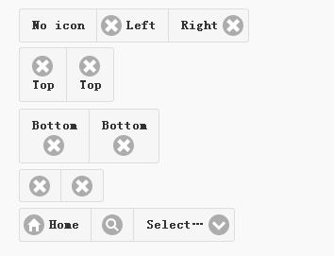

<div data-role="controlgroup" data-type="horizontal" data-mini="true">

    <a href="#" class="ui-btn ui-corner-all">No icon</a>

    <a href="#" class="ui-btn ui-corner-all ui-icon-delete ui-btn-icon-left">Left</a>

    <a href="#" class="ui-btn ui-corner-all ui-icon-delete ui-btn-icon-right">Right</a>

</div>

<div data-role="controlgroup" data-type="horizontal" data-mini="true">

    <a href="#" class="ui-btn ui-corner-all ui-icon-delete ui-btn-icon-top">Top</a>

    <a href="#" class="ui-btn ui-corner-all ui-icon-delete ui-btn-icon-top">Top</a>

</div>

<div data-role="controlgroup" data-type="horizontal" data-mini="true">

    <a href="#" class="ui-btn ui-corner-all ui-icon-delete ui-btn-icon-bottom">Bottom</a>

    <a href="#" class="ui-btn ui-corner-all ui-icon-delete ui-btn-icon-bottom">Bottom</a>

</div>

<div data-role="controlgroup" data-type="horizontal" data-mini="true">

    <a href="#" class="ui-btn ui-corner-all ui-icon-delete ui-btn-icon-notext">Icon only</a>

    <a href="#" class="ui-btn ui-corner-all ui-icon-delete ui-btn-icon-notext">Icon only</a>

</div>

<form>

    <fieldset data-role="controlgroup" data-type="horizontal" data-mini="true">

        <button data-icon="home">Home</button>

        <button data-icon="search" data-iconpos="notext">Search</button>

        <label for="select-more-2a" class="ui-hidden-accessible">More</label>

        <select name="select-more-2a" id="select-more-2a">

            <option value="">Select…</option>

            <option value="#">One</option>

            <option value="#">Two</option>

            <option value="#">Three</option>

        </select>

    </fieldset>

</form>

## 单选垂直导航按钮

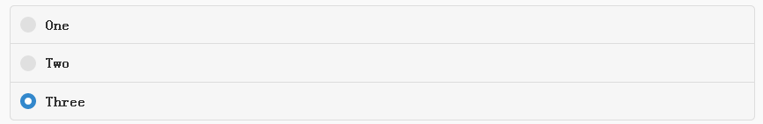

<form>

<fieldset data-role="controlgroup">

    <legend>Vertical:</legend>

    <input type="radio" name="radio-choice-v-2" id="radio-choice-v-2a" value="on" checked="checked">

    <label for="radio-choice-v-2a">One</label>

    <input type="radio" name="radio-choice-v-2" id="radio-choice-v-2b" value="off">

    <label for="radio-choice-v-2b">Two</label>

    <input type="radio" name="radio-choice-v-2" id="radio-choice-v-2c" value="other">

    <label for="radio-choice-v-2c">Three</label>

</fieldset>

</form>

迷你型单选垂直导航按钮

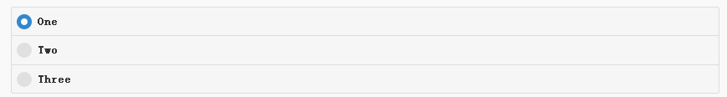

<form>

<fieldset data-role="controlgroup" data-mini="true">

    <legend>Vertical, mini sized:</legend>

    <input type="radio" name="radio-choice-v-6" id="radio-choice-v-6a" value="on" checked="checked">

    <label for="radio-choice-v-6a">One</label>

    <input type="radio" name="radio-choice-v-6" id="radio-choice-v-6b" value="off">

    <label for="radio-choice-v-6b">Two</label>

    <input type="radio" name="radio-choice-v-6" id="radio-choice-v-6c" value="other">

    <label for="radio-choice-v-6c">Three</label>

</fieldset>

</form>

## 单选水平导航按钮



<form>

<fieldset data-role="controlgroup" data-type="horizontal">

    <legend>Horizontal:</legend>

    <input type="radio" name="radio-choice-h-2" id="radio-choice-h-2a" value="on" checked="checked">

    <label for="radio-choice-h-2a">One</label>

    <input type="radio" name="radio-choice-h-2" id="radio-choice-h-2b" value="off">

    <label for="radio-choice-h-2b">Two</label>

    <input type="radio" name="radio-choice-h-2" id="radio-choice-h-2c" value="other">

    <label for="radio-choice-h-2c">Three</label>

</fieldset>

</form>

单选水平迷你导航按钮



<form>

<fieldset data-role="controlgroup" data-type="horizontal" data-mini="true">

    <legend>Horizontal, mini sized:</legend>

    <input type="radio" name="radio-choice-h-6" id="radio-choice-h-6a" value="on" checked="checked">

    <label for="radio-choice-h-6a">One</label>

    <input type="radio" name="radio-choice-h-6" id="radio-choice-h-6b" value="off">

    <label for="radio-choice-h-6b">Two</label>

    <input type="radio" name="radio-choice-h-6" id="radio-choice-h-6c" value="other">

    <label for="radio-choice-h-6c">Three</label>

</fieldset>

</form>

## 复选垂直导航按钮

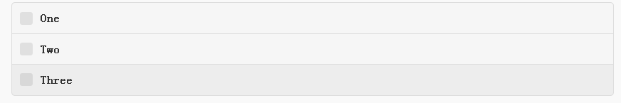

<form>

<fieldset data-role="controlgroup">

    <legend>Vertical:</legend>

    <input type="checkbox" name="checkbox-v-2a" id="checkbox-v-2a">

    <label for="checkbox-v-2a">One</label>

    <input type="checkbox" name="checkbox-v-2b" id="checkbox-v-2b">

    <label for="checkbox-v-2b">Two</label>

    <input type="checkbox" name="checkbox-v-2c" id="checkbox-v-2c">

    <label for="checkbox-v-2c">Three</label>

</fieldset>

</form>

复选垂直迷你导航按钮

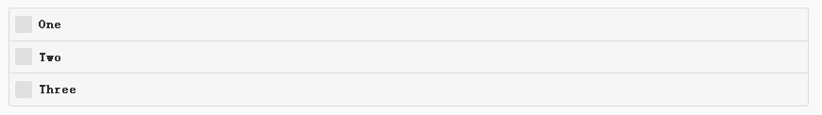

<form>

<fieldset data-role="controlgroup" data-mini="true">

    <legend>Vertical, mini sized:</legend>

    <input type="checkbox" name="checkbox-v-6a" id="checkbox-v-6a">

    <label for="checkbox-v-6a">One</label>

    <input type="checkbox" name="checkbox-v-6b" id="checkbox-v-6b">

    <label for="checkbox-v-6b">Two</label>

    <input type="checkbox" name="checkbox-v-6c" id="checkbox-v-6c">

    <label for="checkbox-v-6c">Three</label>

</fieldset>

</form>

## 复选水平导航按钮

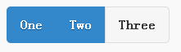

<form>

<fieldset data-role="controlgroup" data-type="horizontal">

    <legend>Horizontal:</legend>

    <input type="checkbox" name="checkbox-h-2a" id="checkbox-h-2a">

    <label for="checkbox-h-2a">One</label>

    <input type="checkbox" name="checkbox-h-2b" id="checkbox-h-2b">

    <label for="checkbox-h-2b">Two</label>

    <input type="checkbox" name="checkbox-h-2c" id="checkbox-h-2c">

    <label for="checkbox-h-2c">Three</label>

</fieldset>

</form>

复选迷你水平导航按钮



<form>

<fieldset data-role="controlgroup" data-type="horizontal" data-mini="true">

    <legend>Horizontal, mini sized:</legend>

    <input type="checkbox" name="checkbox-h-6a" id="checkbox-h-6a">

    <label for="checkbox-h-6a">One</label>

    <input type="checkbox" name="checkbox-h-6b" id="checkbox-h-6b">

    <label for="checkbox-h-6b">Two</label>

    <input type="checkbox" name="checkbox-h-6c" id="checkbox-h-6c">

    <label for="checkbox-h-6c">Three</label>

</fieldset>

</form>

## 下拉垂直导航按钮

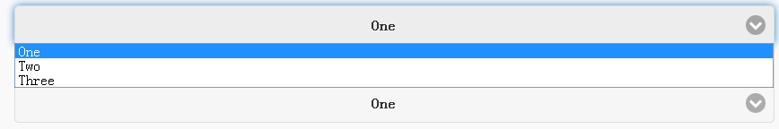

<form>

<fieldset data-role="controlgroup">

    <legend>Vertical:</legend>

    <label for="select-v-2a">Select A</label>

    <select name="select-v-2a" id="select-v-2a">

        <option value="#">One</option>

        <option value="#">Two</option>

        <option value="#">Three</option>

    </select>

    <label for="select-v-2b">Select B</label>

    <select name="select-v-2b" id="select-v-2b">

        <option value="#">One</option>

        <option value="#">Two</option>

        <option value="#">Three</option>

    </select>

    <label for="select-v-2c">Select C</label>

    <select name="select-v-2c" id="select-v-2c">

        <option value="#">One</option>

        <option value="#">Two</option>

        <option value="#">Three</option>

    </select>

</fieldset>

</form>

下拉垂直迷你导航按钮

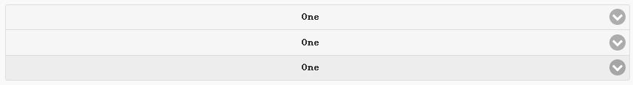

<form>

<fieldset data-role="controlgroup" data-mini="true">

    <legend>Vertical, mini sized:</legend>

    <label for="select-v-6a">Select A</label>

    <select name="select-v-6a" id="select-v-6a">

        <option value="#">One</option>

        <option value="#">Two</option>

        <option value="#">Three</option>

    </select>

    <label for="select-v-6b">Select B</label>

    <select name="select-v-6b" id="select-v-6b">

        <option value="#">One</option>

        <option value="#">Two</option>

        <option value="#">Three</option>

    </select>

    <label for="select-v-6c">Select C</label>

    <select name="select-v-6c" id="select-v-6c">

        <option value="#">One</option>

        <option value="#">Two</option>

        <option value="#">Three</option>

    </select>

</fieldset>

</form>

## 下拉水平导航按钮

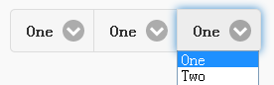

<form>

<fieldset data-role="controlgroup" data-type="horizontal">

    <legend>Horizontal:</legend>

    <label for="select-h-2a">Select A</label>

    <select name="select-h-2a" id="select-h-2a">

        <option value="#">One</option>

        <option value="#">Two</option>

        <option value="#">Three</option>

    </select>

    <label for="select-h-2b">Select B</label>

    <select name="select-h-2b" id="select-h-2b">

        <option value="#">One</option>

        <option value="#">Two</option>

        <option value="#">Three</option>

    </select>

    <label for="select-h-2c">Select C</label>

    <select name="select-h-2c" id="select-h-2c">

        <option value="#">One</option>

        <option value="#">Two</option>

        <option value="#">Three</option>

    </select>

</fieldset>

</form>

下拉水平迷你导航按钮



<form>

<fieldset data-role="controlgroup" data-type="horizontal" data-mini="true">

    <legend>Horizontal, mini sized:</legend>

    <label for="select-h-6a">Select A</label>

    <select name="select-h-6a" id="select-h-6a">

        <option value="#">One</option>

        <option value="#">Two</option>

        <option value="#">Three</option>

    </select>

    <label for="select-h-6b">Select B</label>

    <select name="select-h-6b" id="select-h-6b">

        <option value="#">One</option>

        <option value="#">Two</option>

        <option value="#">Three</option>

    </select>

    <label for="select-h-6c">Select C</label>

    <select name="select-h-6c" id="select-h-6c">

        <option value="#">One</option>

        <option value="#">Two</option>

        <option value="#">Three</option>

    </select>

</fieldset>

</form>

## 文本输入框导航

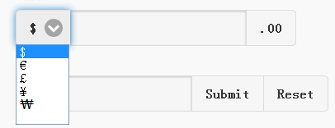

<label for="currency-controlgroup">Value</label>

<div data-role="controlgroup" data-type="horizontal">

    <select>

        <option>$</option>

        <option>€</option>

        <option>£</option>

        <option>¥</option>

        <option>₩</option>

        <option>₹</option>

    </select>

    <input id="currency-controlgroup" type="text" data-wrapper-class="controlgroup-textinput ui-btn">

    <button>.00</button>

</div>

<label for="search-control-group">Search</label>

<div data-role="controlgroup" data-type="horizontal">

    <input type="text" id="search-control-group" data-wrapper-class="controlgroup-textinput ui-btn">

    <button>Submit</button>

    <button>Reset</button>

</div>

.controlgroup-textinput{

    padding-top:.22em;

    padding-bottom:.22em;

}

## 动态添加导航按钮

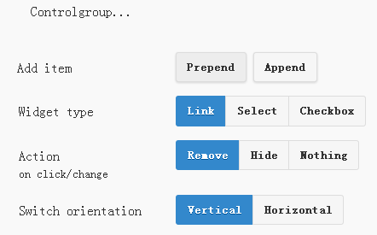

<form>

    <div class="ui-body ui-body-d ui-corner-all">

        <p>Controlgroup...</p>

        <div data-role="controlgroup" id="my-controlgroup"><!-- items will be injected here --></div>

    </div>

</form>

<div class="ui-field-contain">

    <label for="prepend">Add item</label>

    <button id="prepend" data-mini="true" data-inline="true">Prepend</button>

    <label for="append" class="ui-hidden-accessible">Action</label>

    <button id="append" data-mini="true" data-inline="true">Append</button>

</div>

<form action="#" method="get">

    <div class="ui-field-contain">

        <fieldset data-role="controlgroup" data-type="horizontal" data-mini="true">

            <legend>Widget type</legend>

            <input type="radio" name="radio-widget" id="link" value="link" checked="checked">

            <label for="link">Link</label>

            <input type="radio" name="radio-widget" id="select" value="select">

            <label for="select">Select</label>

            <input type="radio" name="radio-widget" id="checkbox" value="checkbox">

            <label for="checkbox">Checkbox</label>

        </fieldset>

    </div>

    <div class="ui-field-contain">

        <fieldset data-role="controlgroup" data-type="horizontal" data-mini="true">

            <legend>Action<br><small>on click/change</small></legend>

            <input type="radio" name="radio-action" id="remove" value="remove" checked="checked">

            <label for="remove">Remove</label>

            <input type="radio" name="radio-action" id="hide" value="hide">

            <label for="hide">Hide</label>

            <input type="radio" name="radio-action" id="width" value="width">

            <label for="width">Nothing</label>

        </fieldset>

    </div>

    <div class="ui-field-contain">

        <fieldset data-role="controlgroup" data-type="horizontal" data-mini="true">

            <legend>Switch orientation</legend>

            <input type="radio" name="radio-orientation" id="isVertical" value="isVertical" checked="checked">

            <label for="isVertical">Vertical</label>

            <input type="radio" name="radio-orientation" id="isHorizontal" value="isHorizontal">

            <label for="isHorizontal">Horizontal</label>

        </fieldset>

    </div>

</form>

( function( $, undefined ) {

    var counter = 0;

    $( document ).bind( "pagecreate", function( e ) {

        $( "#prepend, #append", e.target ).on( "click", function( e ) {

            counter++;

            var widgetType = $( "[name='radio-widget']:checked" ).attr( "id" ),

                group = $( "#my-controlgroup" ),

                $el,

                action = function() {

                    var action = $( "[name='radio-action']:checked" ).attr( "id" );

                    if ( $( $el[1] ).is( "select" ) && action === "hide" ) {

                        $el = $( $el[1] ).parents( ".ui-select" );

                    }

                    $el[ action ]();

                    group.controlgroup( "refresh" );

                };

            if ( widgetType === "link" ) {

                $el = $( "<a href='#'>Link " + counter + "</a>" ).bind( "click", action );

                $( "#my-controlgroup" ).controlgroup( "container" )[ $( this ).attr( "id" ) ]( $el );

                $el.buttonMarkup();

            } else if ( widgetType === "select" ) {

                $el = $( "<label for='widget" + counter + "'>Select " + counter + "</label><select id='widget" + counter + "'><option value='option1'>Select " + counter + "</option><option value='option2'>Select option</option></select>" );

                $( $el[ 1 ] ).bind( "change", action);

                $( "#my-controlgroup" ).controlgroup( "container" )[ $( this ).attr( "id" ) ]( $el );

                $( $el[ 1 ] ).selectmenu();

            } else {

                $el = $( "<label for='widget" + counter + "'>Checkbox " + counter + "</label><input type='checkbox' id='widget" + counter + "'></input>" );

                $( $el[ 1 ] ).bind( "change", action );

                $( "#my-controlgroup" ).controlgroup( "container" )[ $( this ).attr( "id" ) ]( $el );

                $( $el[ 1 ] ).checkboxradio();

            }

            group.controlgroup( "refresh" );

        });

        $( "[name='radio-orientation']" ).bind( "change", function( e ) {

            $( "#my-controlgroup" ).controlgroup( "option", "type", ( $( "#isHorizontal" ).is( ":checked" ) ? "horizontal" : "vertical" ) );

        });

    });

})( jQuery );

# 日期选择组件

## 弹出选择



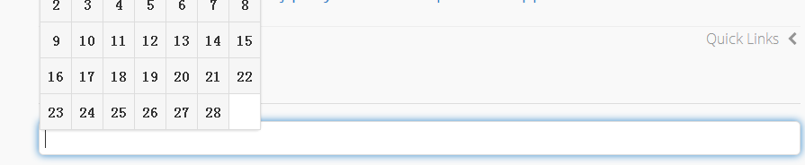

<input type="text" data-role="date">

## 内嵌选择

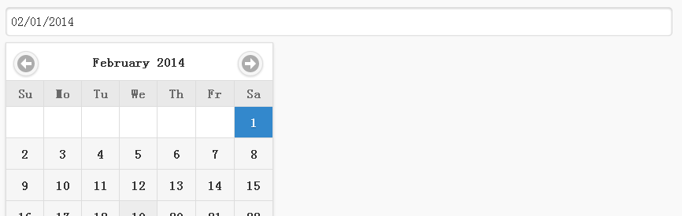

<input type="text" data-role="date" data-inline="true">

# 事件

## 列表滑动删除

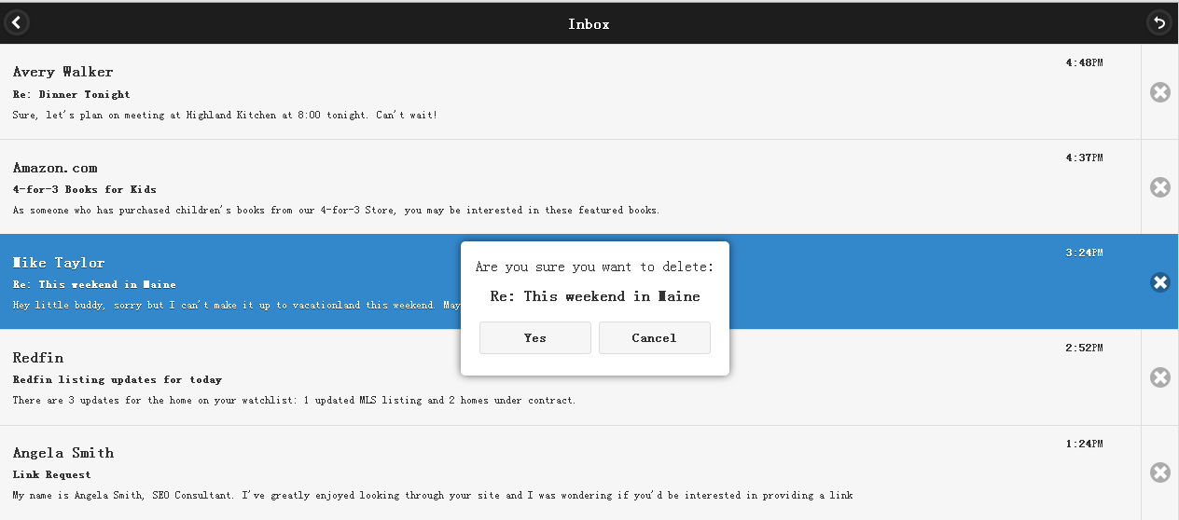

<div data-role="page" id="demo-page" data-title="Inbox" data-url="demo-page">

    <div data-role="header" data-position="fixed" data-theme="b">

        <h1>Inbox</h1>

        <a href="#demo-intro" data-rel="back" data-icon="carat-l" data-iconpos="notext">Back</a>

        <a href="#" onclick="window.location.reload()" data-icon="back" data-iconpos="notext">Refresh</a>

    </div><!-- /header -->

    <div role="main" class="ui-content">

        <ul id="list" class="touch" data-role="listview" data-icon="false" data-split-icon="delete">

            <li>

                <a href="#demo-mail">

                    <h3>Avery Walker</h3>

                    <p class="topic"><strong>Re: Dinner Tonight</strong></p>

                    <p>Sure, let's plan on meeting at Highland Kitchen at 8:00 tonight. Can't wait! </p>

                    <p class="ui-li-aside"><strong>4:48</strong>PM</p>

                </a>

                <a href="#" class="delete">Delete</a>

            </li>

            <li>

                <a href="#demo-mail">

                    <h3>Amazon.com</h3>

                    <p class="topic"><strong>4-for-3 Books for Kids</strong></p>

                    <p>As someone who has purchased children's books from our 4-for-3 Store, you may be interested in these featured books.</p>

                    <p class="ui-li-aside"><strong>4:37</strong>PM</p>

                </a>

                <a href="#" class="delete">Delete</a>

            </li>

            <li>

                <a href="#demo-mail">

                    <h3>Mike Taylor</h3>

                    <p class="topic"><strong>Re: This weekend in Maine</strong></p>

                    <p>Hey little buddy, sorry but I can't make it up to vacationland this weekend. Maybe next weekend?</p>

                    <p class="ui-li-aside"><strong>3:24</strong>PM</p>

                </a>

                <a href="#" class="delete">Delete</a>

            </li>

            <li>

                <a href="#demo-mail">

                    <h3>Redfin</h3>

                    <p class="topic"><strong>Redfin listing updates for today</strong></p>

                    <p>There are 3 updates for the home on your watchlist: 1 updated MLS listing and 2 homes under contract.</p>

                    <p class="ui-li-aside"><strong>2:52</strong>PM</p>

                </a>

                <a href="#" class="delete">Delete</a>

            </li>

            <li>

                <a href="#demo-mail">

                    <h3>Angela Smith</h3>

                    <p class="topic"><strong>Link Request</strong></p>

                    <p>My name is Angela Smith, SEO Consultant. I've greatly enjoyed looking through your site and I was wondering if you'd be interested in providing a link</p>

                    <p class="ui-li-aside"><strong>1:24</strong>PM</p>

                </a>

                <a href="#" class="delete">Delete</a>

            </li>

            <li>

                <a href="#demo-mail">

                    <h3>Stephen Weber</h3>

                    <p class="topic"><strong>You've been invited to a meeting at Filament Group in Boston, MA</strong></p>

                    <p>Hey Stephen, if you're available at 10am tomorrow, we've got a meeting with the jQuery team.</p>

                    <p class="ui-li-aside"><strong>11:24</strong>AM</p>

                </a>

                <a href="#" class="delete">Delete</a>

            </li>

            <li>

                <a href="#demo-mail">

                    <h3>jQuery Team</h3>

                    <p class="topic"><strong>Boston Conference Planning</strong></p>

                    <p>In preparation for the upcoming conference in Boston, we need to start gathering a list of sponsors and speakers.</p>

                    <p class="ui-li-aside"><strong>9:18</strong>AM</p>

                </a>

                <a href="#" class="delete">Delete</a>

            </li>

            <li>

                <a href="#demo-mail">

                    <h3>Avery Walker</h3>

                    <p class="topic"><strong>Re: Dinner Tonight</strong></p>

                    <p>Sure, let's plan on meeting at Highland Kitchen at 8:00 tonight. Can't wait! </p>

                    <p class="ui-li-aside"><strong>4:48</strong>PM</p>

                </a>

                <a href="#" class="delete">Delete</a>

            </li>

            <li>

                <a href="#demo-mail">

                    <h3>Amazon.com</h3>

                    <p class="topic"><strong>4-for-3 Books for Kids</strong></p>

                    <p>As someone who has purchased children's books from our 4-for-3 Store, you may be interested in these featured books.</p>

                    <p class="ui-li-aside"><strong>4:37</strong>PM</p>

                </a>

                <a href="#" class="delete">Delete</a>

            </li>

            <li>

                <a href="#demo-mail">

                    <h3>Mike Taylor</h3>

                    <p class="topic"><strong>Re: This weekend in Maine</strong></p>

                    <p>Hey little buddy, sorry but I can't make it up to vacationland this weekend. Maybe next weekend?</p>

                    <p class="ui-li-aside"><strong>3:24</strong>PM</p>

                </a>

                <a href="#" class="delete">Delete</a>

            </li>

            <li>

                <a href="#demo-mail">

                    <h3>Redfin</h3>

                    <p class="topic"><strong>Redfin listing updates for today</strong></p>

                    <p>There are 3 updates for the home on your watchlist: 1 updated MLS listing and 2 homes under contract.</p>

                    <p class="ui-li-aside"><strong>2:52</strong>PM</p>

                </a>

                <a href="#" class="delete">Delete</a>

            </li>

            <li>

                <a href="#demo-mail">

                    <h3>Angela Smith</h3>

                    <p class="topic"><strong>Link Request</strong></p>

                    <p>My name is Angela Smith, SEO Consultant. I've greatly enjoyed looking through your site and I was wondering if you'd be interested in providing a link</p>

                    <p class="ui-li-aside"><strong>1:24</strong>PM</p>

                </a>

                <a href="#" class="delete">Delete</a>

            </li>

            <li>

                <a href="#demo-mail">

                    <h3>Stephen Weber</h3>

                    <p class="topic"><strong>You've been invited to a meeting at Filament Group in Boston, MA</strong></p>

                    <p>Hey Stephen, if you're available at 10am tomorrow, we've got a meeting with the jQuery team.</p>

                    <p class="ui-li-aside"><strong>11:24</strong>AM</p>

                </a>

                <a href="#" class="delete">Delete</a>

            </li>

            <li>

                <a href="#demo-mail">

                    <h3>jQuery Team</h3>

                    <p class="topic"><strong>Boston Conference Planning</strong></p>

                    <p>In preparation for the upcoming conference in Boston, we need to start gathering a list of sponsors and speakers.</p>

                    <p class="ui-li-aside"><strong>9:18</strong>AM</p>

                </a>

                <a href="#" class="delete">Delete</a>

            </li>

        </ul>

    </div><!-- /content -->

    <div id="confirm" class="ui-content" data-role="popup" data-theme="a">

        <p id="question">Are you sure you want to delete:</p>

        <div class="ui-grid-a">

            <div class="ui-block-a">

                <a id="yes" class="ui-btn ui-corner-all ui-mini ui-btn-a" data-rel="back">Yes</a>

            </div>

            <div class="ui-block-b">

                <a id="cancel" class="ui-btn ui-corner-all ui-mini ui-btn-a" data-rel="back">Cancel</a>

            </div>

        </div>

    </div><!-- /popup -->

</div>

$( document ).on( "pagecreate", "#demo-page", function() {

    // Swipe to remove list item

    $( document ).on( "swipeleft swiperight", "#list li", function( event ) {

        var listitem = $( this ),

            // These are the classnames used for the CSS transition

            dir = event.type === "swipeleft" ? "left" : "right",

            // Check if the browser supports the transform (3D) CSS transition

            transition = $.support.cssTransform3d ? dir : false;

            confirmAndDelete( listitem, transition );

    });

    // If it's not a touch device...

    if ( ! $.mobile.support.touch ) {

        // Remove the class that is used to hide the delete button on touch devices

        $( "#list" ).removeClass( "touch" );

        // Click delete split-button to remove list item

        $( ".delete" ).on( "click", function() {

            var listitem = $( this ).parent( "li" );

            confirmAndDelete( listitem );

        });

    }

    function confirmAndDelete( listitem, transition ) {

        // Highlight the list item that will be removed

        listitem.children( ".ui-btn" ).addClass( "ui-btn-active" );

        // Inject topic in confirmation popup after removing any previous injected topics

        $( "#confirm .topic" ).remove();

        listitem.find( ".topic" ).clone().insertAfter( "#question" );

        // Show the confirmation popup

        $( "#confirm" ).popup( "open" );

        // Proceed when the user confirms

        $( "#confirm #yes" ).on( "click", function() {

            // Remove with a transition

            if ( transition ) {

                listitem

                    // Add the class for the transition direction

                    .addClass( transition )

                    // When the transition is done...

                    .on( "webkitTransitionEnd transitionend otransitionend", function() {

                        // ...the list item will be removed

                        listitem.remove();

                        // ...the list will be refreshed and the temporary class for border styling removed

                        $( "#list" ).listview( "refresh" ).find( ".border-bottom" ).removeClass( "border-bottom" );

                    })

                    // During the transition the previous button gets bottom border

                    .prev( "li" ).children( "a" ).addClass( "border-bottom" )

                    // Remove the highlight

                    .end().end().children( ".ui-btn" ).removeClass( "ui-btn-active" );

            }

            // If it's not a touch device or the CSS transition isn't supported just remove the list item and refresh the list

            else {

                listitem.remove();

                $( "#list" ).listview( "refresh" );

            }

        });

        // Remove active state and unbind when the cancel button is clicked

        $( "#confirm #cancel" ).on( "click", function() {

            listitem.removeClass( "ui-btn-active" );

            $( "#confirm #yes" ).off();

        });

    }

});

/* Left transition */

li.left {

    -webkit-transition: -webkit-transform 250ms ease;

    -webkit-transform: translateX(-100%);

    -moz-transition: -moz-transform 250ms ease;

    -moz-transform: translateX(-100%);

    -o-transition: -o-transform 250ms ease;

    -o-transform: translateX(-100%);

    transition: transform 250ms ease;

    transform: translateX(-100%);

}

/* Right transition */

li.right {

    -webkit-transition: -webkit-transform 250ms ease;

    -webkit-transform: translateX(100%);

    -moz-transition: -moz-transform 250ms ease;

    -moz-transform: translateX(100%);

    -o-transition: -o-transform 250ms ease;

    -o-transform: translateX(100%);

    transition: transform 250ms ease;

    transform: translateX(100%);

}

/* Border bottom for the previous button during the transition*/

li.left a.ui-btn,

li.right a.ui-btn {

    border-top-width: 0;

    border-left-width: 1px;

    border-right-width: 1px;

}

li a.ui-btn.border-bottom {

    border-bottom-width: 1px;

}

/* Hide the delete button on touch devices */

ul.touch li.ui-li-has-alt a.delete {

    display: none;

}

ul.touch li.ui-li-has-alt a.ui-btn {

    margin-right:0;

}

/* Styling for the popup */

#confirm p {

    text-align: center;

    font-size: inherit;

    margin-bottom: .75em;

}

## 滑动页面切换

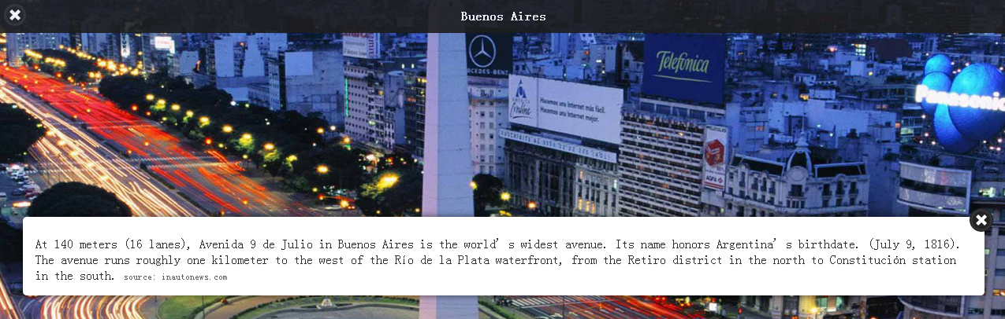

<div data-role="page" id="city" class="demo-page" data-dom-cache="true" data-theme="b" data-prev="prevCity" data-next="nextCity" data-url="city">

    <div role="main" class="ui-content">

        <div id="trivia-city" class="trivia ui-content" data-role="popup" data-position-to="window" data-tolerance="50,30,30,30" data-theme="a">

            <a href="#" data-rel="back" class="ui-btn ui-btn-right ui-btn-b ui-btn-icon-notext ui-icon-delete ui-corner-all">Close</a>

            <p>Here some text.</p>

        </div><!-- /popup -->

    </div><!-- /content -->

</div>

// Pagecreate will fire for each of the pages in this demo

// but we only need to bind once so we use "one()"

$( document ).one( "pagecreate", ".demo-page", function() {

    // Initialize the external persistent header and footer

    $( "#header" ).toolbar({ theme: "b" });

    $( "#footer" ).toolbar({ theme: "b" });

    // Handler for navigating to the next page

    function navnext( next ) {

        $( ":mobile-pagecontainer" ).pagecontainer( "change", next + ".html", {

            transition: "slide"

        });

    }

    // Handler for navigating to the previous page

    function navprev( prev ) {

        $( ":mobile-pagecontainer" ).pagecontainer( "change", prev + ".html", {

            transition: "slide",

            reverse: true

        });

    }

    // Navigate to the next page on swipeleft

    $( document ).on( "swipeleft", ".ui-page", function( event ) {

        // Get the filename of the next page. We stored that in the data-next

        // attribute in the original markup.

        var next = $( this ).jqmData( "next" );

        // Check if there is a next page and

        // swipes may also happen when the user highlights text, so ignore those.

        // We're only interested in swipes on the page.

        if ( next && ( event.target === $( this )[ 0 ] ) ) {

            navnext( next );

        }

    });

    // Navigate to the next page when the "next" button in the footer is clicked

    $( document ).on( "click", ".next", function() {

        var next = $( ".ui-page-active" ).jqmData( "next" );

        // Check if there is a next page

        if ( next ) {

            navnext( next );

        }

    });

    // The same for the navigating to the previous page

    $( document ).on( "swiperight", ".ui-page", function( event ) {

        var prev = $( this ).jqmData( "prev" );

        if ( prev && ( event.target === $( this )[ 0 ] ) ) {

            navprev( prev );

        }

    });

    $( document ).on( "click", ".prev", function() {

        var prev = $( ".ui-page-active" ).jqmData( "prev" );

        if ( prev ) {

            navprev( prev );

        }

    });

});

$( document ).on( "pageshow", ".demo-page", function() {

    var thePage = $( this ),

        title = thePage.jqmData( "title" ),

        next = thePage.jqmData( "next" ),

        prev = thePage.jqmData( "prev" );

    // Point the "Trivia" button to the popup for the current page.

    $( "#trivia-button" ).attr( "href", "#" + thePage.find( ".trivia" ).attr( "id" ) );

    // We use the same header on each page

    // so we have to update the title

    $( "#header h1" ).text( title );

    // Prefetch the next page

    // We added data-dom-cache="true" to the page so it won't be deleted

    // so there is no need to prefetch it

    if ( next ) {

        $( ":mobile-pagecontainer" ).pagecontainer( "load", next + ".html" );

    }

    // We disable the next or previous buttons in the footer

    // if there is no next or previous page

    // We use the same footer on each page

    // so first we remove the disabled class if it is there

    $( ".next.ui-state-disabled, .prev.ui-state-disabled" ).removeClass( "ui-state-disabled" );

    if ( ! next ) {

        $( ".next" ).addClass( "ui-state-disabled" );

    }

    if ( ! prev ) {

        $( ".prev" ).addClass( "ui-state-disabled" );

    }

});

/* Set the background image sources */

#newyork { background-image: url("../_assets/img/newyork.jpg"); }

#buenosaires { background-image: url("../_assets/img/buenosaires.jpg"); }

#paris { background-image: url("../_assets/img/paris.jpg"); }

#capetown { background-image: url("../_assets/img/capetown.jpg"); }

#seoul { background-image: url("../_assets/img/seoul.jpg"); }

#sydney { background-image: url("../_assets/img/sydney.jpg"); }

/* Background settings */

.demo-page {

    background-size: cover;

    background-position: center center;

    background-repeat: no-repeat;

}

/* Transparent footer */

.demo-page .ui-footer {

    background: none;

    border: none;

    bottom: 0;

}

/* The footer won't have a height because there are only two absolute positioned elements in it.

So we position the buttons from the bottom. */

.control.ui-btn-left,

.trivia-btn.ui-btn-right {

    top: auto;

    bottom: 7px;

    margin: 0;

}

/* Custom styling for the trivia source */

small {

    font-size: .75em;

    color: #666;

}

# 筛选过滤组件

## 基本筛选过滤

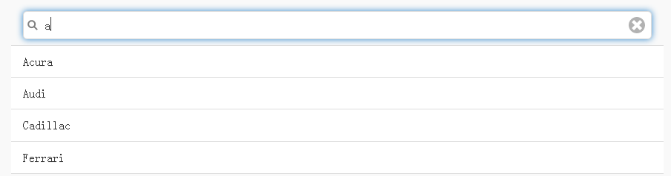

<form class="ui-filterable">

    <input id="filterBasic-input" data-type="search">

</form>

<ul data-role="listview" data-filter="true" data-input="#filterBasic-input">

    <li>Acura</li>

    <li>Audi</li>

    <li>BMW</li>

    <li>Cadillac</li>

    <li>Ferrari</li>

</ul>

## 表记录筛选过滤

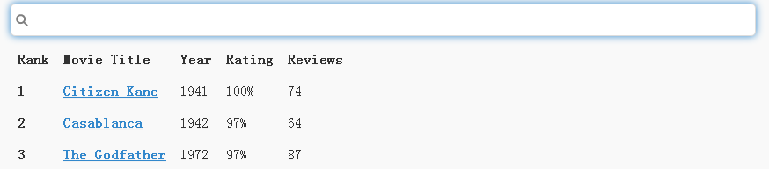

<form>

    <input id="filterTable-input" data-type="search">

</form>

<table data-role="table" id="movie-table" data-filter="true" data-input="#filterTable-input" class="ui-responsive">

    <thead>

        <tr>

            <th data-priority="1">Rank</th>

            <th data-priority="persist">Movie Title</th>

            <th data-priority="2">Year</th>

            <th data-priority="3"><abbr title="Rotten Tomato Rating">Rating</abbr></th>

            <th data-priority="4">Reviews</th>

        </tr>

        </thead>

        <tbody>

            <tr>

                <th>1</th>

                <td><a href="http://en.wikipedia.org/wiki/Citizen_Kane" data-rel="external">Citizen Kane</a></td>

                <td>1941</td>

                <td>100%</td>

                <td>74</td>

            </tr>

            <tr>

                <th>2</th>

                <td><a href="http://en.wikipedia.org/wiki/Casablanca_(film)" data-rel="external">Casablanca</a></td>

                <td>1942</td>

                <td>97%</td>

                <td>64</td>

            </tr>

            <tr>

                <th>3</th>

                <td><a href="http://en.wikipedia.org/wiki/The_Godfather" data-rel="external">The Godfather</a></td>

                <td>1972</td>

                <td>97%</td>

                <td>87</td>

            </tr>

        </tbody>

    </table>

## 导航按钮筛选过滤

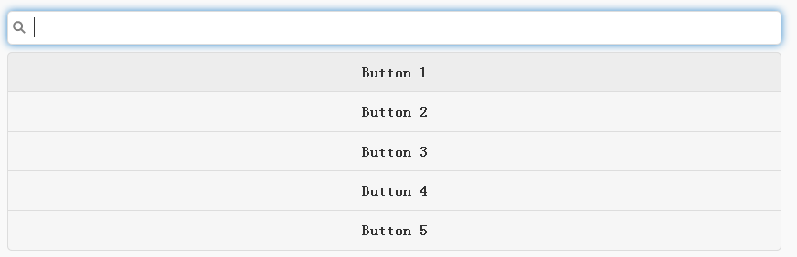

<form>

    <input data-type="search" id="filterControlgroup-input">

</form>

<div data-role="controlgroup" data-filter="true" data-input="#filterControlgroup-input">

    <a href="#" class="ui-btn ui-shadow ui-corner-all">Button 1</a>

    <a href="#" class="ui-btn ui-shadow ui-corner-all">Button 2</a>

    <a href="#" class="ui-btn ui-shadow ui-corner-all" data-filtertext="some text">Button 3</a>

    <a href="#" class="ui-btn ui-shadow ui-corner-all">Button 4</a>

    <a href="#" class="ui-btn ui-shadow ui-corner-all">Button 5</a>

</div>

## 导航下拉框筛选过滤

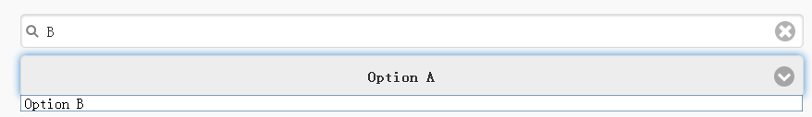

<form>

    <input data-type="search" id="searchForSelect">

</form>

<select id="anotherSelect" data-filter="true" data-input="#searchForSelect">

    <option value="A">Option A</option>

    <option value="B">Option B</option>

    <option value="C">Option C</option>

    <option value="D">Option D</option>

    <option value="E">Option E</option>

    <option value="F">Option F</option>

    <option value="G">Option G</option>

    <option value="H">Option H</option>

    <option value="I">Option I</option>

    <option value="J">Option J</option>

</select>

## 导航可折叠标题筛选过滤

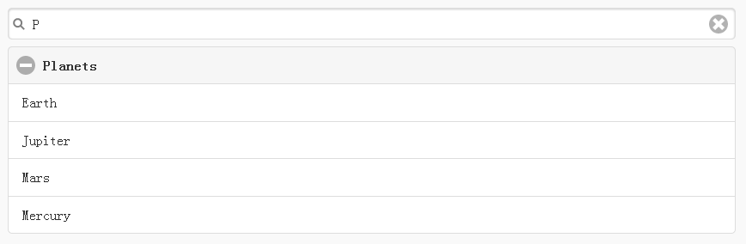

<form>

    <input data-type="search" id="searchForCollapsibleSet">

</form>

    <div data-role="collapsibleset" data-filter="true" data-inset="true" id="collapsiblesetForFilter" data-input="#searchForCollapsibleSet">

        <div data-role="collapsible" data-filtertext="Animals">

            <h3>Animals</h3>

            <ul data-role="listview" data-inset="false">

                <li>Cats</li>

                <li>Dogs</li>

                <li>Lizards</li>

                <li>Snakes</li>

            </ul>

        </div>

        <div data-role="collapsible" data-filtertext="Cars">

            <h3>Cars</h3>

            <ul data-role="listview" data-inset="false">

                <li>Acura</li>

                <li>Audi</li>

                <li>BMW</li>

                <li>Cadillac</li>

            </ul>

        </div>

        <div data-role="collapsible" data-filtertext="Planets">

            <h3>Planets</h3>

            <ul data-role="listview" data-inset="false">

                <li>Earth</li>

                <li>Jupiter</li>

                <li>Mars</li>

                <li>Mercury</li>

            </ul>

        </div>

    </div>

## 导航可折叠内容筛选过滤

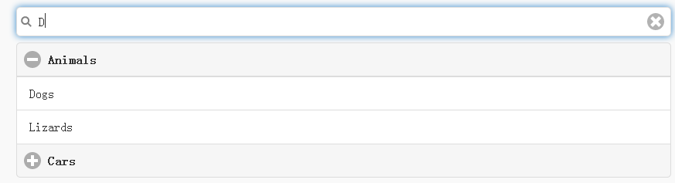

<form>

    <input data-type="search" id="searchForCollapsibleSetChildren">

</form>

    <div data-role="collapsibleset" data-filter="true" data-children="> div, > div div ul li" data-inset="true" id="collapsiblesetForFilterChildren" data-input="#searchForCollapsibleSetChildren">

        <div data-role="collapsible" data-filtertext="Animals Cats Dogs Lizards snakes">

            <h3>Animals</h3>

            <ul data-role="listview" data-inset="false">

                <li data-filtertext="Animals Cats">Cats</li>

                <li data-filtertext="Animals Dogs">Dogs</li>

                <li data-filtertext="Animals Lizards">Lizards</li>

                <li data-filtertext="Animals Snakes">Snakes</li>

            </ul>

        </div>

        <div data-role="collapsible" data-filtertext="Cars Acura Audi BMW Cadillac">

            <h3>Cars</h3>

            <ul data-role="listview" data-inset="false">

                <li data-filtertext="Cars Acura">Acura</li>

                <li data-filtertext="Cars Audi">Audi</li>

                <li data-filtertext="Cars BMW">BMW</li>

                <li data-filtertext="Cars Cadillac">Cadillac</li>

            </ul>

        </div>

        <div data-role="collapsible" data-filtertext="Planets Earth Jupiter Mars Mercury">

            <h3>Planets</h3>

            <ul data-role="listview" data-inset="false">

                <li data-filtertext="Planets Acura">Earth</li>

                <li data-filtertext="Planets Jupiter">Jupiter</li>

                <li data-filtertext="Planets Mars">Mars</li>

                <li data-filtertext="Planets Mercury">Mercury</li>

            </ul>

        </div>

    </div>

## 筛选过滤其他

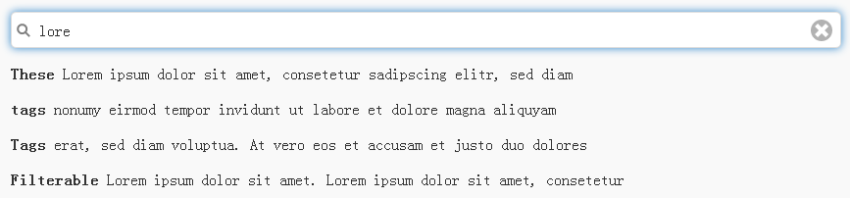

<form>

    <input data-type="search" id="divOfPs-input">

</form>

<div class="elements" data-filter="true" data-input="#divOfPs-input">

<p><strong>These</strong> Lorem ipsum dolor sit amet, consetetur sadipscing elitr, sed diam</p>

<p><strong>tags</strong> nonumy eirmod tempor invidunt ut labore et dolore magna aliquyam</p>

<p><strong>Tags</strong> erat, sed diam voluptua. At vero eos et accusam et justo duo dolores </p>

<p><strong>are</strong> et ea rebum. Stet clita kasd gubergren, no sea takimata sanctus est</p>

<p><strong>Filterable</strong> Lorem ipsum dolor sit amet. Lorem ipsum dolor sit amet, consetetur</p>

</div>

## 其他过滤事件的回调

研究官方文档

# 滑动开关

## 基本型开关

 

<form>

    <label for="flip-checkbox-1">Flip toggle switch checkbox:</label>

    <input type="checkbox" data-role="flipswitch" name="flip-checkbox-1" id="flip-checkbox-1">

</form>

## 自定义型开关

 

<form>

    <label for="flip-checkbox-2">Flip toggle switch checkbox:</label>

    <input type="checkbox" data-role="flipswitch" name="flip-checkbox-2" id="flip-checkbox-2" data-on-text="Light" data-off-text="Dark" data-wrapper-class="custom-label-flipswitch">

</form>

/* Custom indentations are needed because the length of custom labels differs from

   the length of the standard labels */

.custom-label-flipswitch.ui-flipswitch .ui-btn.ui-flipswitch-on {

    text-indent: -3.4em;

}

.custom-label-flipswitch.ui-flipswitch .ui-flipswitch-off {

    text-indent: 0.5em;

}

## 迷你型开关



<form>

    <label for="flip-3">Flip toggle switch:</label>

    <select name="flip-3" id="flip-3" data-role="flipswitch" data-mini="true">

        <option value="off">Off</option>

        <option value="on">On</option>

    </select>

</form>

## 无样式开关



<form>

    <label for="flip-8">Flip toggle switch:</label>

    <select name="flip-8" id="flip-8" data-role="flipswitch" data-corners="false">

        <option value="off">Off</option>

        <option value="on">On</option>

    </select>

</form>

## 失效开关



<form>

    <label for="flip-4">Flip toggle switch:</label>

    <select name="flip-4" id="flip-4" data-role="flipswitch" disabled="disabled">

        <option value="off">Off</option>

        <option value="on">On</option>

    </select>

</form>

# 表单

## 常规按钮

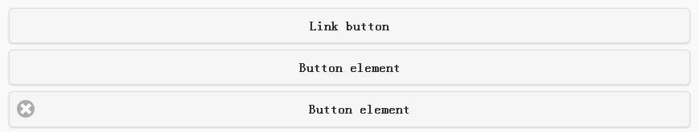

<a href="#" class="ui-shadow ui-btn ui-corner-all">Link button</a>

<button class="ui-shadow ui-btn ui-corner-all">Button element</button>

<input type="button" value="Button element" data-icon="delete" data-theme="a">

## 内嵌按钮

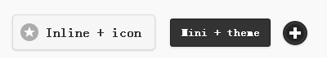

<a href="#" class="ui-shadow ui-btn ui-corner-all ui-btn-inline ui-btn-icon-left ui-icon-star">Inline + icon</a>

<a href="#" class="ui-shadow ui-btn ui-corner-all ui-btn-inline ui-btn-b ui-mini">Mini + theme</a>

<a href="#" class="ui-shadow ui-btn ui-corner-all ui-btn-inline ui-icon-plus ui-btn-icon-notext ui-btn-b ui-mini">icon only button</a>

## 水平分组按钮



<div data-role="controlgroup" data-type="horizontal" data-mini="true">

    <a href="#" class="ui-shadow ui-btn ui-corner-all ui-btn-icon-left ui-icon-plus ui-btn-b">Add</a>

    <a href="#" class="ui-shadow ui-btn ui-corner-all ui-btn-icon-left ui-icon-delete ui-btn-b">Delete</a>

    <a href="#" class="ui-shadow ui-btn ui-corner-all ui-btn-icon-left ui-icon-grid ui-btn-b">More</a>

</div>

## 滑块



<label for="slider">Slider:</label>

<input type="range" name="slider" id="slider" value="50" min="0" max="100">



<label for="slider-fill-mini">Slider with fill, mini, track theme:</label>

<input type="range" name="slider-fill-mini" id="slider-fill-mini" value="40" min="0" max="100" data-mini="true" data-highlight="true" data-theme="b" data-track-theme="b">

## 滑块范围



<form>

    <div data-role="rangeslider">

        <label for="range-1a">Rangeslider:</label>

        <input type="range" name="range-1a" id="range-1a" min="0" max="100" value="40">

        <label for="range-1b">Rangeslider:</label>

        <input type="range" name="range-1b" id="range-1b" min="0" max="100" value="80">

    </div>

</form>

迷你型



<form>

    <div data-role="rangeslider" data-mini="true">

        <label for="range-2a">Mini rangeslider:</label>

        <input type="range" name="range-2a" id="range-2a" min="0" max="100" value="40">

        <label for="range-2b">Mini rangeslider:</label>

        <input type="range" name="range-2b" id="range-2b" min="0" max="100" value="80">

    </div>

</form>

## 轻触开关



<label for="slider2">Flip switch:</label>

<select name="slider2" id="slider2" data-role="slider">

    <option value="off">Off</option>

    <option value="on">On</option>

</select>

迷你型



<label for="slider-flip-m">Mini flip switch:</label>

<select name="slider-flip-m" id="slider-flip-m" data-role="slider" data-mini="true">

    <option value="off">No</option>

    <option value="on" selected="">Yes</option>

</select>

## 复选框

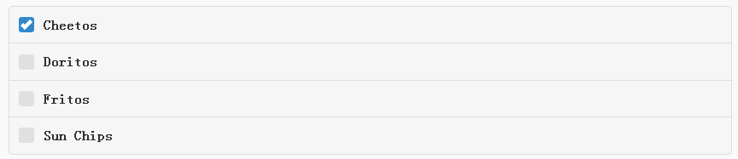

<fieldset data-role="controlgroup">

    <legend>Checkboxes, vertical controlgroup:</legend>

    <input type="checkbox" name="checkbox-1a" id="checkbox-1a" checked="">

    <label for="checkbox-1a">Cheetos</label>

    <input type="checkbox" name="checkbox-2a" id="checkbox-2a">

    <label for="checkbox-2a">Doritos</label>

    <input type="checkbox" name="checkbox-3a" id="checkbox-3a">

    <label for="checkbox-3a">Fritos</label>

    <input type="checkbox" name="checkbox-4a" id="checkbox-4a">

    <label for="checkbox-4a">Sun Chips</label>

</fieldset>

水平复选框



<fieldset data-role="controlgroup" data-type="horizontal" data-mini="true">

    <legend>Checkboxes, mini, horizontal controlgroup:</legend>

    <input type="checkbox" name="checkbox-6" id="checkbox-6">

    <label for="checkbox-6">b</label>

    <input type="checkbox" name="checkbox-7" id="checkbox-7" checked="">

    <label for="checkbox-7"><em>i</em></label>

    <input type="checkbox" name="checkbox-8" id="checkbox-8">

    <label for="checkbox-8">u</label>

</fieldset>

## 单选按钮

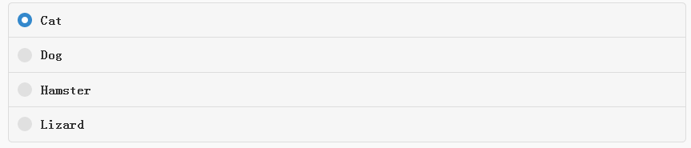

<fieldset data-role="controlgroup">

    <legend>Radio buttons, vertical controlgroup:</legend>

        <input type="radio" name="radio-choice-1" id="radio-choice-1" value="choice-1" checked="checked">

        <label for="radio-choice-1">Cat</label>

        <input type="radio" name="radio-choice-1" id="radio-choice-2" value="choice-2">

        <label for="radio-choice-2">Dog</label>

        <input type="radio" name="radio-choice-1" id="radio-choice-3" value="choice-3">

        <label for="radio-choice-3">Hamster</label>

        <input type="radio" name="radio-choice-1" id="radio-choice-4" value="choice-4">

        <label for="radio-choice-4">Lizard</label>

</fieldset>

水平单选按钮



<fieldset data-role="controlgroup" data-type="horizontal" data-mini="true">

    <legend>Radio buttons, mini, horizontal controlgroup:</legend>

        <input type="radio" name="radio-choice-b" id="radio-choice-c" value="list" checked="checked">

        <label for="radio-choice-c">List</label>

        <input type="radio" name="radio-choice-b" id="radio-choice-d" value="grid">

        <label for="radio-choice-d">Grid</label>

        <input type="radio" name="radio-choice-b" id="radio-choice-e" value="gallery">

        <label for="radio-choice-e">Gallery</label>

</fieldset>

## 下拉框

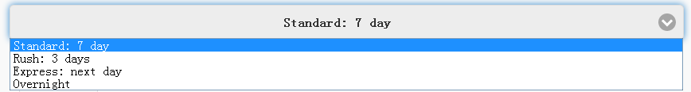

<label for="select-choice-1" class="select">Select, native menu</label>

<select name="select-choice-1" id="select-choice-1">

    <option value="standard">Standard: 7 day</option>

    <option value="rush">Rush: 3 days</option>

    <option value="express">Express: next day</option>

    <option value="overnight">Overnight</option>

</select>

迷你下拉框

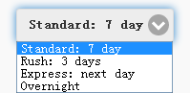

<label for="select-choice-mini" class="select">Mini select, inline</label>

<select name="select-choice-mini" id="select-choice-mini" data-mini="true" data-inline="true">

    <option value="standard">Standard: 7 day</option>

    <option value="rush">Rush: 3 days</option>

    <option value="express">Express: next day</option>

    <option value="overnight">Overnight</option>

</select>

自定义下拉框



<label for="select-choice-a" class="select">Custom select menu:</label>

<select name="select-choice-a" id="select-choice-a" data-native-menu="false">

    <option>Custom menu example</option>

    <option value="standard">Standard: 7 day</option>

    <option value="rush">Rush: 3 days</option>

    <option value="express">Express: next day</option>

    <option value="overnight">Overnight</option>

</select>

图标式下拉框



<label for="select-choice-8" class="select">Multi-select with optgroups, custom icon and position:</label>

<select name="select-choice-8" id="select-choice-8" multiple="multiple" data-native-menu="false" data-icon="grid" data-iconpos="left">

    <option>Choose a few options:</option>

    <optgroup label="USPS">

        <option value="standard" selected="">Standard: 7 day</option>

        <option value="rush">Rush: 3 days</option>

        <option value="express">Express: next day</option>

        <option value="overnight">Overnight</option>

    </optgroup>

    <optgroup label="FedEx">

        <option value="firstOvernight">First Overnight</option>

        <option value="expressSaver">Express Saver</option>

        <option value="ground">Ground</option>

    </optgroup>

</select>

## 文本输入框



<label for="text-basic">Text input:</label>

<input type="text" name="text-basic" id="text-basic" value="">

## 文本域输入框

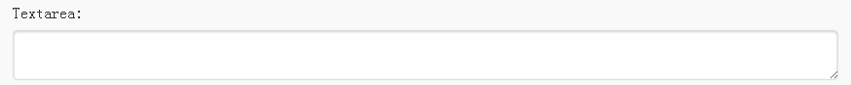

<label for="textarea">Textarea:</label>

<textarea cols="40" rows="8" name="textarea" id="textarea"></textarea>

## 数字输入选择框



<label for="number-pattern">Number + [0-9]* pattern:</label>

<input type="number" name="number" pattern="[0-9]*" id="number-pattern" value="">

## 日期选择输入框



<label for="date">Date:</label>

<input type="date" name="date" id="date" value="">

## 电话输入框



<label for="tel">Tel:</label>

<input type="tel" name="tel" id="tel" value="">

## 搜索输入框



<label for="search">Search Input:</label>

<input type="search" name="password" id="search" value="" placeholder="Placeholder text...">

## 文件选择框



<label for="file">File:</label>

<input type="file" name="file" id="file" value="">

## 密码输入框



<label for="password">Password:</label>

<input type="password" name="password" id="password" value="" autocomplete="off">

## 初始化内容输入框



<label for="textinput-hide" class="ui-hidden-accessible">Text Input:</label>

<input type="text" name="textinput-hide" id="textinput-hide" placeholder="Text input" value="">

## 禁止输入框



<div class="ui-field-contain">

    <label for="textinput-disabled">Text Input:</label>

    <input disabled="disabled" type="text" name="textinput-disabled" id="textinput-disabled" placeholder="Text input" value="">

</div>

## 同行标注输入框



<div class="ui-field-contain">

    <label for="textinput-fc">Text Input:</label>

    <input type="text" name="textinput-fc" id="textinput-fc" placeholder="Text input" value="">

</div>

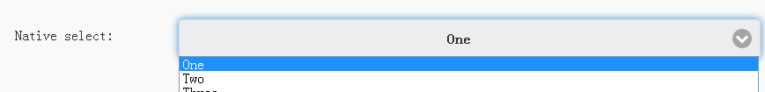

<div class="ui-field-contain">

    <label for="select-native-fc">Native select:</label>

    <select name="select-native-fc" id="select-native-fc">

        <option value="small">One</option>

        <option value="medium">Two</option>

        <option value="large">Three</option>

    </select>

</div>

## 动态生成表单元素

